Source: HEAD acoustics GmbH, Knowles Inc., Orange, Sony Mobile Communications
Title: Results of the Round Robin Test on Different Background Noise Simulation Techniques for Hand-Held Hands-Free Terminals
Document for: Discussion
Agenda Item: 10.5

Table of Content
Table of Content 1
1 Summary 4
2 Introduction 4
3 General test setup 4
4 HHHF: Comparison of inter-lab accuracy for the different background noise simulation methods 5
4.1 Dealing with outliers 6
4.2 Wideband 7
4.2.1 No background noise 7
4.2.2 Background Noises & Simulation acc. to ES 202 396-1 9
4.2.3 Simulation acc. to ES 202 396-1 with noises from TS 103 224 (binaural) 11
4.2.4 Background Noises & Simulation acc. to TS 103 224 13
4.3 Narrowband 15
4.3.1 No background noise 15
4.3.2 Background Noises & Simulation acc. to ES 202 396-1 16
4.3.3 Simulation acc. to ES 202 396-1 with noises from TS 103 224 (binaural) 18
4.3.4 Background Noises & Simulation acc. to TS 103 224 21
5 HHHF: Comparison of measurement results between ES 202 396-1 and TS 103 224 background noise simulation technique 23
5.1 Wideband 23
5.1.1 Background Noises & Simulation acc. to ES 202 396-1 compared to TS 103 224 simulation 23
5.1.2 Simulation acc. to ES 202 396-1 with noises from TS 103 224 (binaural) compared to TS 103 224 simulation 25
5.2 Narrowband 27
5.2.1 Background Noises & Simulation acc. to ES 202 396-1 compared to TS 103 224 simulation 27
5.2.2 Simulation acc. to ES 202 396-1 with noises from TS 103 224 (binaural) compared to TS 103 224 simulation 29
6 HHHF: Analysis results according to TS 26.131 & TS 26.132 31
6.1 Wideband 31
6.1.1 Absolute Values 31
6.1.2 Differences between TS 103 224 and ES 202 396-1 32
G-MOS 32
S-MOS 32
N-MOS 32
6.1.3 TS 103 224 - ES 202 396-1 with noises from TS 103 224 33
G-MOS 33
S-MOS 33
N-MOS 33
6.2 Narrowband 34
6.2.1 Absolute Values 34
6.2.2 Differences between TS 103 224 and ES 202 396-1 35
G-MOS 35
S-MOS 35
N-MOS 35
6.2.3 TS 103 224 - ES 202 396-1 with noises from TS 103 224 36
G-MOS 36
S-MOS 36
N-MOS 36
7 HHHF: Analyses of the noise spectra reproduced at the reference microphone 37
7.1 Simulation acc. to ES 202 396-1 with recordings from TS 103 224, reference recording at place of DUT-microphone 37
Cafeteria 37
Crossroad 38
Inside Car 38
Office 39
Pub 39
Trainstation 40
7.2 Simulation & Recordings acc. to TS 103 224, reference recording at place of DUT-microphone 41
Cafeteria 41
Crossroad 42
Inside Car 42
Office 43
Pub 43
Trainstation 44
8 DTHF: Comparison of inter-lab accuracy for the different background noise simulation methods 45
8.1 Wideband 45
8.1.1 No background noise 45
8.1.2 Simulation acc. to ES 202 396-1 with noises from TS 103 224 (binaural) 47
8.1.3 Background Noises & Simulation acc. to TS 103 224 49
8.2 Narrowband 51
8.2.1 No background noise 51
8.2.2 Simulation acc. to ES 202 396-1 with noises from TS 103 224 (binaural) 53
8.2.3 Background Noises & Simulation acc. to TS 103 224 55
9 DTHF:Comparison of measurement results between ES 202 396-1 and TS 103 224 background noise simulation technique 57
9.1 Wideband 57
9.1.1 Simulation acc. to ES 202 396-1 with noises from TS 103 224 (binaural) compared to TS 103 224 simulation 57
9.2 Narrowband 58
9.2.1 Simulation acc. to ES 202 396-1 with noises from TS 103 224 (binaural) compared to TS 103 224 simulation 58
10 DTHF:Analysis results according to TS 26.131 & TS 26.132 59
10.1 Wideband 59
10.1.1 Absolute Values 59
10.1.2 TS 103 224 - ES 202 396-1 with noises from TS 103 224 60
G-MOS 60
S-MOS 60
N-MOS 60
10.2 Narrowband 61
10.2.1 Absolute Values 61
10.2.2 TS 103 224 - ES 202 396-1 with noises from TS 103 224 62
G-MOS 62
S-MOS 62
N-MOS 62
11 DTHF: Analyses of the noise spectra reproduced at the reference microphone 63
11.1 Simulation acc. to ES 202 396-1 with recordings from TS 103 224, reference recording at place of DUT-microphone 63
Desktop Office 63
11.2 Simulation & Recordings acc. to TS 103 224, reference recording at place of DUT-microphone 64
Desktop Office 64
12 Conclusions 65
13 References 65

Summary
This document summarizes the results of a Round Robin test conducted between April and August 2015. The document introduces the results and analyzes the accuracy of the different simulation methods when used in different labs. It furthermore shows the impact of the different analysis methods on the results measured with different mobile terminals.

Introduction
The aim of the Round Robin test conducted under the ATeMPO_SPINE work item [1] was mainly to answer the following questions:
- How good is the reproducibility of the different methods?
- Are there differences in the measured performance when using the different devices with different setups?
The following labs were participating in the test:
- Audience Inc.
- HEAD acoustics GmbH
- Orange
- Sony Mobile Communications
In the Round Robin test 7 different devices were used, some labs tested only a subset of 6 devices as agreed upon in advance. Not all labs conducted the full set of tests in Narrowband and Wideband. At HEAD acoustics two rooms were used to conduct the tests, in all other labs the tests were conducted in one room.
For measurements using the ES 202 396-1 background playback methodology, occasional playback problems were observed in the 2.1 lab. This explains the outliers and might have partly contributed to some other (lower) MOS values for this lab, for this playback method. The overall tendencies observed in the complete data set are not strongly affected by these issues.

General test setup
In order to minimize all variabilities coming from other sources than the different setups and rooms used all test and the sequencing of all tests was prepared by HEAD acoustics and provided to all test labs. All labs used HEAD acoustics ACQUA with the HAE-BGN and 3PASS background noise systems with the identical database. All data were integrated in a final database containing the results of all labs. Based on this procedure it was easy to perform all types of analyses as needed for the Round Robin experiment.
The selection of the rooms was up to the test labs. However, the requirements as found in [2] and [3] was followed. The detailed test setup is described in the individual reports of the test labs ([4], [7], [8], [9]).
Figure 1and Figure 2 show the general test setup for the two background noise simulation methods.

Figure 1: General setup of the 4+1 loudspeaker arrangement according to ES 202 396-1 [2]

Figure 2: General setup of the 8 loudspeaker arrangement according to TS 103 224 [3]

The calibration of the setups was made by each lab individually. The calibration procedures as described in [2] and [3] which are integrated in HAE-BGN and 3PASS were followed by each lab. The calibration results are found in the individual test reports of the test labs.

HHHF: Comparison of inter-lab accuracy for the different background noise simulation methods
In this section we compare the S- N- G- MOS results as measured in the different rooms with the different terminals. The comparison is focused on the accuracy of the different background noise simulation systems. The comparison is made for each method and each set of background noise separately. Arbitrarily one room can be taken as a reference and the results measured in the other rooms are referred to this reference room. In our case Lab 2.1 was taken as a reference room since at Sony all tests were conducted with all devices
The following plots show the differences between the (arbitrarily chosen) Sony test room (RT60 = 140 ms) and the other rooms:
 | Lab | Rev. Time T60 | Clarity Index C80
Lab 1.1 | HEAD acoustics Room 1 | 125 ms | 37.1 dB
Lab 1.2 | HEAD acoustics Room 2 | 240 ms | 20.5 dB
Lab 2.1 | Sony | 139 ms | 30.0 dB
Lab 3.1 | Audience | 117 ms | 29.2 dB
Lab 4.1 | Orange 0° | 89 ms | 40 dB
Lab 4.2 | Orange 22.5° | 89 ms | 40 dB

Seven Phones were available for testing from which six phones were tested in every lab.

Name | Size
DUT1 | 138.1 x 67 x 6.9 mm
DUT2 | 143.4 x 70.5 x 6.8 mm
DUT3 | 138.5 x 70.9 x 8.9 mm
DUT4 | 162.8 x 85.4 x 8.7 mm
DUT5 | 127.3 x 64.9 x 8.6 mm
DUT6 | 150.1 x 72.7 x 9.6 mm
DUT7 | 157.7 x 78.7 x 7.7 mm

Dealing with outliers
Four outliers could be observed which could clearly be traced back to an error in the measurement setup and therefore do not represent any characteristics of the background noise generation method used. In this chapter the diagrams contain these outliers while the RMSE-values are calculated without outliers. In the following chapter these outliers are ignored.
The outliers are:
Bandwidth | EQ-method | Backgroundnoise | Lab | DUT
Narrowband | ES 202 396-1 | Inside Car | Lab 2.1 | DUT2
Narrowband | ES 202 396-1 with noises from TS 103 224 | Inside Car | Lab 2.1 | DUT2
Wideband | ES 202 396-1 with noises from TS 103 224 | Inside Car | Lab 3.1 | DUT2
Wideband | TS 103 224 | Office | Lab 4.2 | DUT7

Wideband

No background noise
In this chapter we see basically the variance to be expected in different labs with no background noise simulation present. This variance may be influenced by:
- Calibration differences
- Setup differences
- Room differences
- Time variant behavior of the device under test
It seems that these parameters may have impact on the results in a similar or even bigger range than the experiments which include the background noise simulation. The main impact is on S-MOS resulting in somewhat scattered G-MOS results as well.

Figure 3: Correlation between G-MOS results from Lab 2.1 and other labs
Figure 4: Correlation between S-MOS results from Lab 2.1 and other labs
Figure 5: Correlation between N-MOS results from Lab 2.1 and other labs

Background Noises & Simulation acc. to ES 202 396-1
The results shown in this section are based on using the ES 2002 396-1 Simulation as well as the background noises from this standard. The following observations can be made:
- Compared to Lab 2.1 the results measured in the other labs are in general about 0.2 to 0.3 MOS higher for N-MOS and G-MOS
- The results are somewhat scattered leading to RMSE values between 0.13 and 0.22
- N-MOS shows the highest variation in results up to about 0.5 MOS

Figure 6: Correlation between G-MOS results from Lab 2.1 and other labs

Figure 7: Correlation between S-MOS results from Lab 2.1 and other labs

Figure 8: Correlation between N-MOS results from Lab 2.1 and other labs

Simulation acc. to ES 202 396-1 with noises from TS 103 224 (binaural)
The results shown in this section are based on using the ES 2002 396-1 Simulation but using the binaurally recorded background noises from TS 103 224. The following observations can be made:
- Compared to Lab 2.1 the results measured in the other labs are in general about 0.3 to 0.4 MOS higher for S-MOS, N-MOS and G-MOS
- The results are somewhat scattered leading to RMSE values between 0.17 and 0.24
- N-MOS shows the highest variation in results up to about 0.5 MOS

Please note that outliers as indicated by the test labs Sony and Audience are excluded from the RMSE calculations.

Outlier in Lab 3
Figure 9: Correlation between G-MOS results from Lab 2.1 and other labs

Figure 10: Correlation between S-MOS results from Lab 2.1 and other labs

Outlier in Lab 3
Figure 11: Correlation between N-MOS results from Lab 2.1 and other labs

Background Noises & Simulation acc. to TS 103 224
The results shown in this section are based on using the TS 103 224 Simulation as well as the background noises from this standard. For this setup the following observations can be made:
- All results line up fairly well, no offset between the labs can be observed
- The results are less scattered leading to low RMSE values of 0.1
- Especially N-MOS is measured very consistent between labs

Figure 12: Correlation between G-MOS results from Lab 2.1 and other labs

Figure 13: Correlation between S-MOS results from Lab 2.1 and other labs

Figure 14: Correlation between N-MOS results from Lab 2.1 and other labs

Narrowband

No background noise
Figure 15: Correlation between G-MOS results from Lab 2.1 and other labs
Figure 16: Correlation between S-MOS results from Lab 2.1 and other labs
Figure 17: Correlation between N-MOS results from Lab 2.1 and other labs

Background Noises & Simulation acc. to ES 202 396-1
The results shown in this section are based on using the ES 2002 396-1 Simulation as well as the background noises from this standard. The following observations can be made:
- Compared to Lab 2.1 the results measured in the other labs are in general about 0.2 to 0.3 MOS higher for N-MOS and G-MOS
- The results are somewhat scattered leading to RMSE values between 0.15 and 0.21
- N-MOS shows the highest variation in results up to about 0.5 MOS

Please note that outliers as indicated by the test labs Sony and Audience are excluded from the RMSE calculations.

Figure 18: Correlation between G-MOS results from Lab 2.1 and other labs

Figure 19: Correlation between S-MOS results from Lab 2.1 and other labs

Outlier in Lab 2
Figure 20: Correlation between N-MOS results from Lab 2.1 and other labs

Simulation acc. to ES 202 396-1 with noises from TS 103 224 (binaural)
The results shown in this section are based on using the ES 2002 396-1 Simulation but using the binaurally recorded background noises from TS 103 224. The following observations can be made:
- Compared to Lab 2.1 the results measured in the other labs are in general about 0.3 to 0.4 MOS higher for S-MOS, N-MOS and G-MOS
- The results are somewhat scattered leading to RMSE values between 0.22 and 0.25
- N-MOS shows the highest variation in results up to about 0.5 MOS
- S-MOS shows a high variation of the results for Pub-noise and Train station noise

Please note that outliers as indicated by the test labs Sony and Audience are excluded from the RMSE calculations.
.

Figure 21: Correlation between G-MOS results from Lab 2.1 and other labs

Figure 22: Correlation between S-MOS results from Lab 2.1 and other labs

Outlier in Lab 2
Figure 23: Correlation between N-MOS results from Lab 2.1 and other labs

Background Noises & Simulation acc. to TS 103 224
The results shown in this section are based on using the TS 103 224 Simulation as well as the background noises from this standard. For this setup the following observations can be made:
- All results line up fairly well, no offset between the labs can be observed
- The results are less scattered leading to low RMSE values between 0.11 and 0.14
- Especially N-MOS values are measured very consistent

Figure 24: Correlation between G-MOS results from Lab 2.1 and other labs

Figure 25: Correlation between S-MOS results from Lab 2.1 and other labs

Figure 26: Correlation between N-MOS results from Lab 2.1 and other labs

HHHF: Comparison of measurement results between ES 202 396-1 and TS 103 224 background noise simulation technique
In this section we compare the S- N- G- MOS results as measured in the different rooms with the different terminals. The comparison is focused on the difference of the different background noise simulation systems. The comparison is made between each method and the different sets of background noises. The results measured using the ETSI ES 202 396-1 background noise simulation system [2]f or all noises in all labs with all terminals are used as the reference. The results measured using the ETSI TS 103 224 simulation system [3] are plotted on the abscissa (y-axis) for comparison.
The results of the different devices are color coded as indicated in the figures.

Wideband

Background Noises & Simulation acc. to ES 202 396-1 compared to TS 103 224 simulation - including differences due to different noise recordings
While for crossroad, inside car office and pub noise the measurements lead to quite comparable results deviations are seen for the cafeteria and train station noise. The reason for these differences is the different nature of the noises in the different noise databases. E.g. the cafeteria noise is in average about 6 dB lower in level for the recordings in EG 202 396-1, the train station noise is about 7 dB higher in level.
G-MOS
Figure 27: Correlation between G-MOS results from method from TS 103 224 and method from ES 202 396-1

S-MOS
Figure 28: Correlation between S-MOS results from method from TS 103 224 and method from ES 202 396-1

N-MOS
Figure 29: Correlation between N-MOS results from method from TS 103 224 and method from ES 202 396-1

Simulation acc. to ES 202 396-1 with noises from TS 103 224 (binaural) compared to TS 103 224 simulation
When choosing the same type of recordings by taking the binaurally recorded noises form TS 103 224 the differences between the methods become smaller, the results line up in general. More variation can be seen for the N-MOS results than for the S-MOS results. This is clearly indicating the difference in the background noise simulation method. The S-MOS seems to be mainly determined by the speech signal which is unchanged in the experiments.

G-MOS
Figure 30: Correlation between G-MOS results from method from TS 103 224 and method from ES 202 396-1 with noises from TS 103 224
S-MOS
Figure 31: Correlation between S-MOS results from method from TS 103 224 and method from ES 202 396-1 with noises from TS 103 224
N-MOS
Figure 32: Correlation between N-MOS results from method from TS 103 224 and method from ES 202 396-1 with noises from TS 103 224

Narrowband

Background Noises & Simulation acc. to ES 202 396-1 compared to TS 103 224 simulation - including differences due to different noise recordings
While for crossroad, inside car office and pub noise the measurements lead to quite comparable results deviations are seen for the cafeteria and train station noise. The reason for these differences is the different nature of the noises in the different noise databases. E.g. the cafeteria noise is in average about 6 dB lower in level for the recordings in EG 202 396-1, the train station noise is about 7 dB higher in level. This observation is similar to the wideband simulation.

G-MOS
Figure 33: Correlation between G-MOS results from method from TS 103 224 and method from ES 202 396-1
S-MOS
Figure 34: Correlation between S-MOS results from method from TS 103 224 and method from ES 202 396-1

N-MOS
Figure 35: Correlation between N-MOS results from method from TS 103 224 and method from ES 202 396-1

Simulation acc. to ES 202 396-1 with noises from TS 103 224 (binaural) compared to TS 103 224 simulation
When choosing the same type of recordings by taking the binaurally recorded noises form TS 103 224 the differences between the methods become smaller, the results line up in general. More variation can be seen for the N-MOS and G-MOS results than for the S-MOS results. This is clearly indicating the difference in the background noise simulation method. The S-MOS seems to be mainly determined by the speech signal which is unchanged in the experiments.

G-MOS
Figure 36: Correlation between G-MOS results from method from TS 103 224 and method from ES 202 396-1 with noises from TS 103 224
S-MOS
Figure 37: Correlation between S-MOS results from method from TS 103 224 and method from ES 202 396-1 with noises from TS 103 224

N-MOS
Figure 38: Correlation between N-MOS results from method from TS 103 224 and method from ES 202 396-1 with noises from TS 103 224

HHHF: Analysis results according to TS 26.131 & TS 26.132
In this chapter we perform the analysis as currently defined in [5] and [6]. The average results, measured in the different labs are shown.

Wideband

Absolute Values
The results in Figure 39 show the same tendency for all phones when measured using the different background noise simulation setups. The rank order in performance remains unchanged.

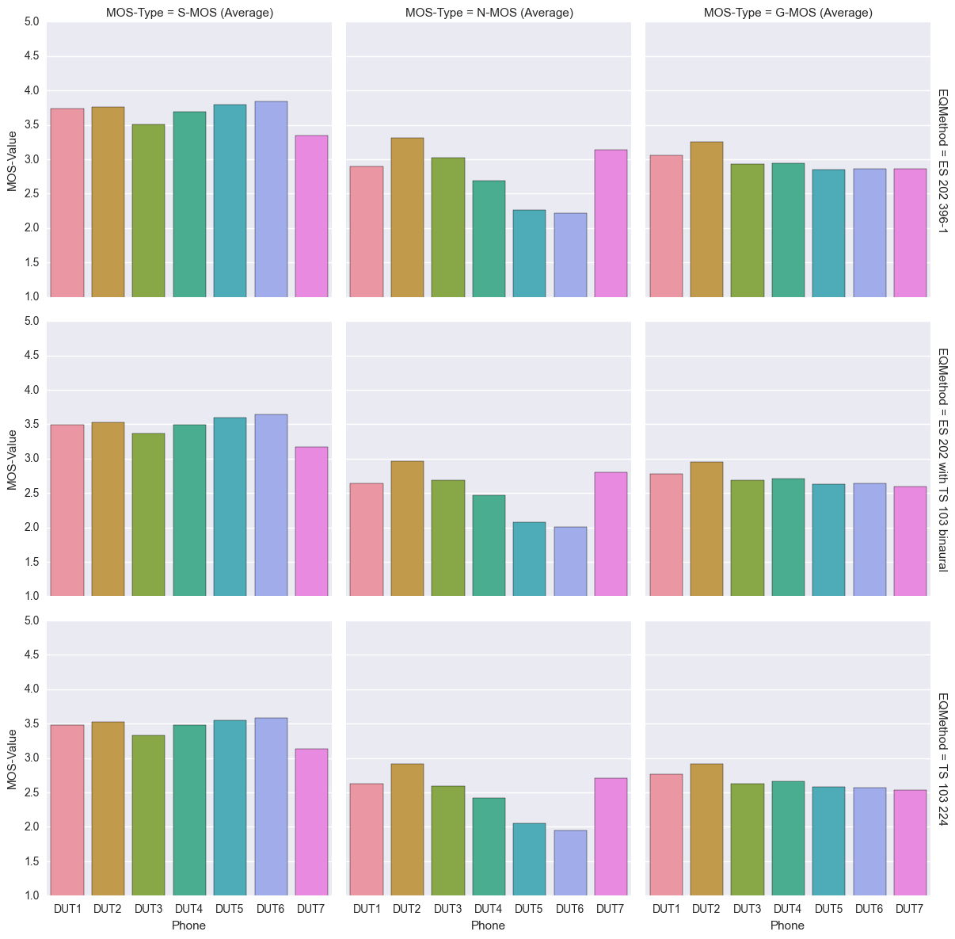
Figure 39: Absolute MOS-Values when values are averaged over all background noises and all labs

Differences between TS 103 224 and ES 202 396-1
Differences in the absolute values when comparing ES 202 396-1 with TS 103 224 can be seen for all terminals (see Figure 40). The offset is not constant but depending on the type of terminal. The main difference is found in the N-MOS values indication the different sensitivity of individual terminals to the different types of noise. The performance for all terminals is better when using the ES 202 396-1. Again, this is due to the less stressing noises in this standard.

G-MOS  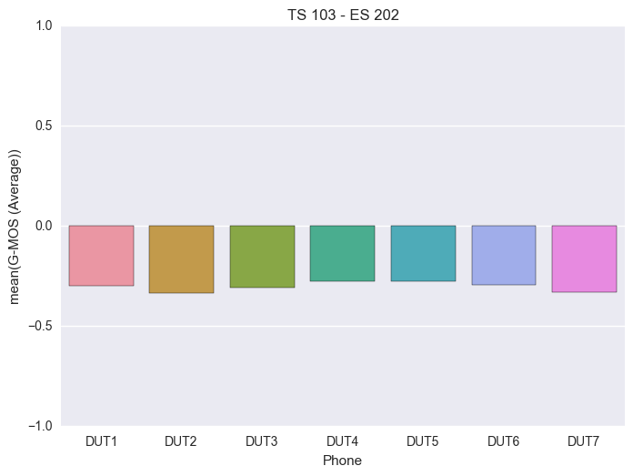 | S-MOS  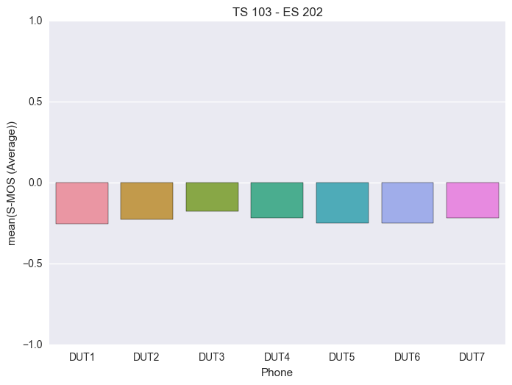

N-MOS
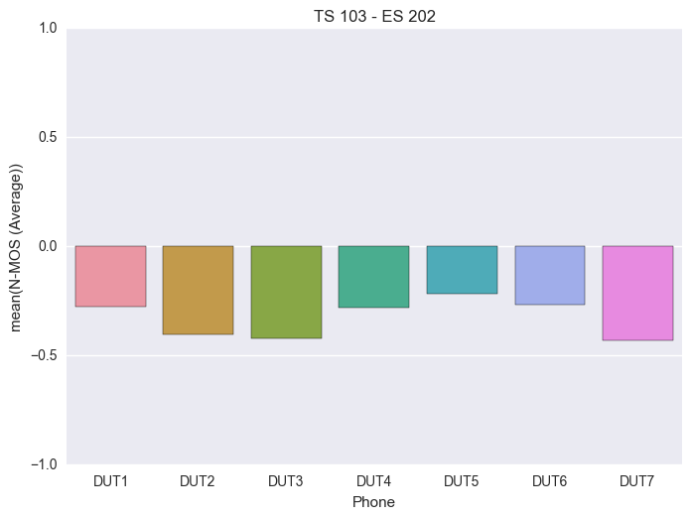
Figure 40: Differences of MOS-values between method from TS 103 224 and method from ES 202 396-1

TS 103 224 - ES 202 396-1 with noises from TS 103 224
When using the binaurally recorded background noises from TS 103 224 for the tests the differences when comparing ES 202 396-1 with TS 103 224 get much smaller (see Figure 41). Again, the offset is not constant but depending on the type of terminal. The performance for all terminals is better when using the ES 202 396-1.Surprisingly the performance for all terminals is slightly better when using the ES 202 396-1 simulation method compared to the sound field simulation technique described in TS 103 224.

G-MOS  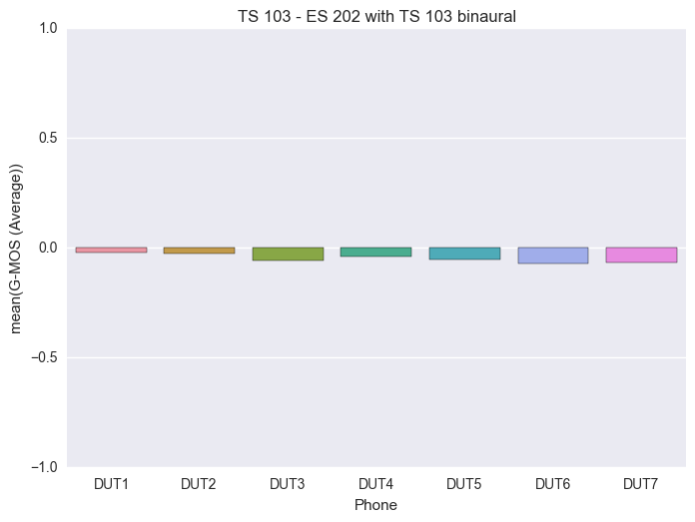 | S-MOS  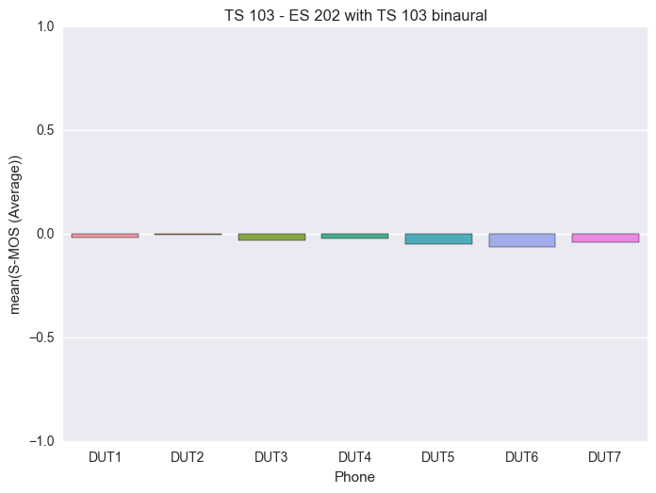

N-MOS
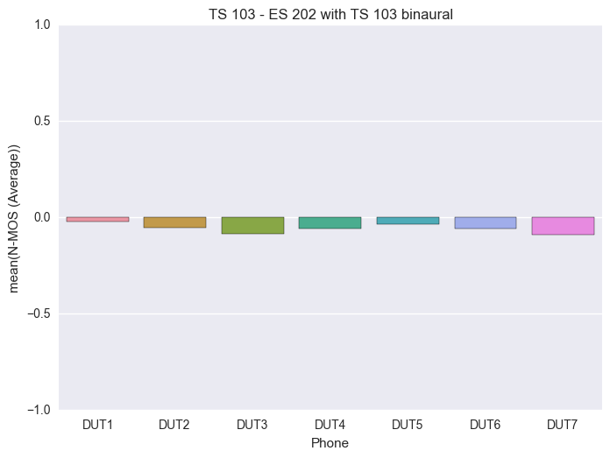
Figure 41: Differences of MOS-values between method from TS 103 224 and ES 202 396-1 with noises from TS 103 224

Narrowband

Absolute Values
The results in Figure 42 show the same tendency for all phones when measured using the different background noise simulation setups. The rank order in performance remains unchanged.
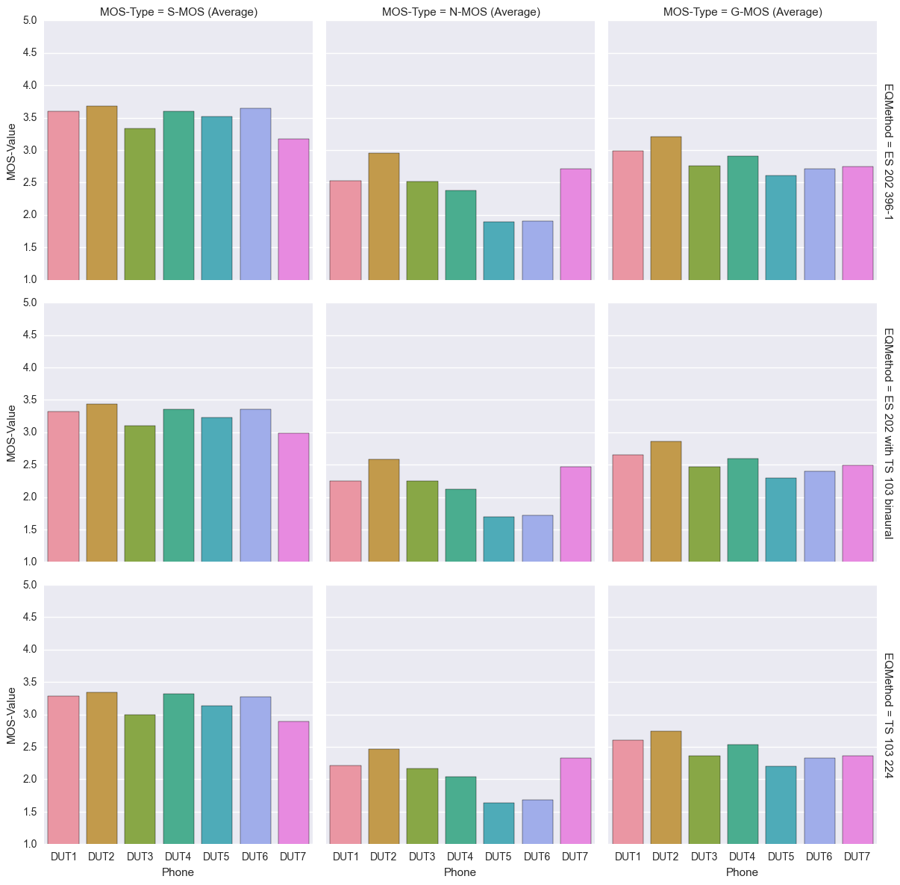
Figure 42: Absolute MOS-Values when values are averaged over all background noises and all labs

Differences between TS 103 224 and ES 202 396-1
Differences in the absolute values when comparing ES 202 396-1 with TS 103 224 can be seen for all terminals (see Figure 43). The offset is not constant but depending on the type of terminal. The differences are found in S-, N-, and G-MOS values. As in wideband the performance for all terminals is better when using the ES 202 396-1. Again, this is due to the less stressing noises in this standard.

G-MOS  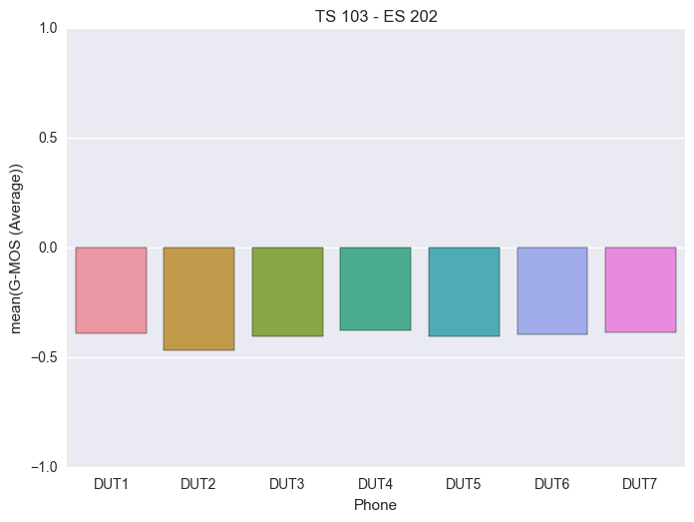 | S-MOS  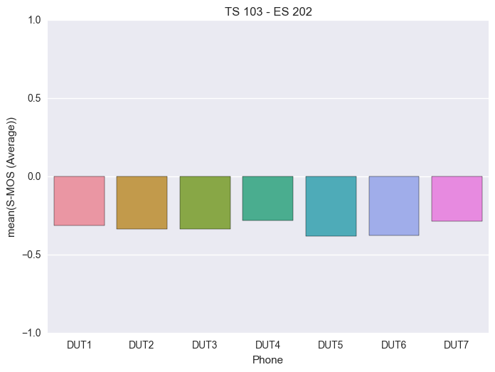

N-MOS
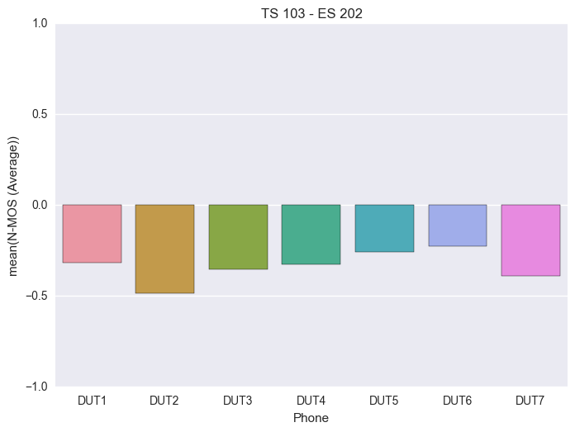
Figure 43: Differences of MOS-values between method from TS 103 224 and method from ES 202 396-1

TS 103 224 - ES 202 396-1 with noises from TS 103 224
When using the binaurally recorded background noises from TS 103 224 for the tests the differences when comparing ES 202 396-1 with TS 103 224 get much smaller (see Figure 44). Again, the offset is not constant but depending on the type of terminal. The performance for all terminals is better when using the ES 202 396-1.Surprisingly the performance for all terminals is slightly better when using the ES 202 396-1 simulation method compared to the sound field simulation technique described in TS 103 224.
G-MOS  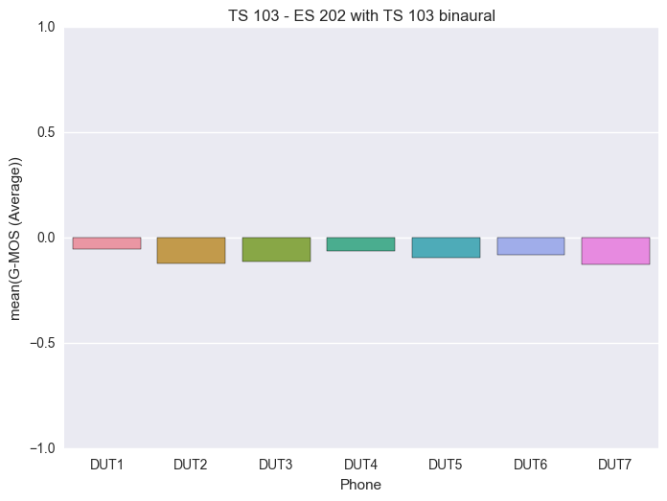 | S-MOS  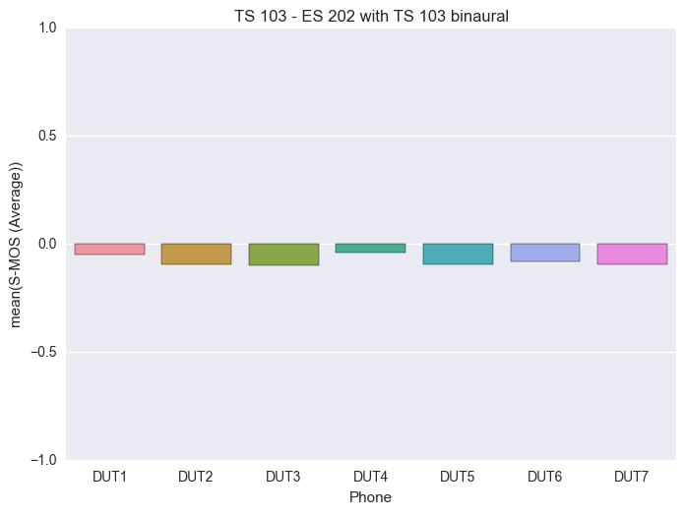

N-MOS
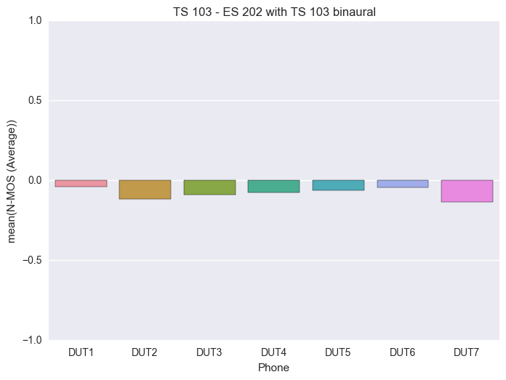
Figure 44: Differences of MOS-values between method from TS 103 224 and ES 202 396-1 with noises from TS 103 224

HHHF: Analyses of the noise spectra reproduced at the reference microphone
The background noises spectra measured at the reference microphone of all devices under test are plotted into one diagram for all background noises which were used in this test. Each diagram contains background noise spectra from
- 6 DUTs from Lab 1 (DUT7 was not measured)
  - Two times because two different rooms were available
- 7 DUTs from Lab 2
- 7 DUTs from Lab 3
- 7 DUTs from Lab 4
  - Two times because two different setups were made

Simulation acc. to ES 202 396-1 with recordings from TS 103 224, reference recording at place of DUT-microphone
For all background noise quite big differences can be found in the spectra reproduced by the ES 202 396-1 simulation method. The differences depend to some extent on the noise type. More uniform background noises such as e.g. car show less spectral variance than e.g. the train station which performs worst.
The differences range from 5 dB up to 15 dB. Consistently big differences are found in the low frequency domain.

Cafeteria
Figure 45: All spectra recorded at reference microphone for cafeteria noise with method from ES 202 396-1 and noises from TS 103 224 in 1/3rd octave

Crossroad
Figure 46: All spectra recorded at reference microphone for crossroad noise with method from ES 202 396-1 and noises from TS 103 224 in 1/3rd octave

Inside Car
Figure 47: All spectra recorded at reference microphone for car noise with method from ES 202 396-1 and noises from TS 103 224 in 1/3rd octave

Office
Figure 48: All spectra recorded at reference microphone for office noise with method from ES 202 396-1 and noises from TS 103 224 in 1/3rd octave

Pub
Figure 49: All spectra recorded at reference microphone for pub noise with method from ES 202 396-1 and noises from TS 103 224 in 1/3rd octave

Trainstation
Figure 50: All spectra recorded at reference microphone for trainstation noise with method from ES 202 396-1 and noises from TS 103 224 in 1/3rd octave

Simulation & Recordings acc. to TS 103 224, reference recording at place of DUT-microphone
The differences in the spectra reproduced by the TS 103 224 simulation method are significantly lower compared to the ES 202 396-1 simulation method. The differences seem to be independent of the noise type.
The differences range from 1 dB up to 10 dB. As expected the sound field reproduction is very consistent between labs in the low frequency domain up to about 2 kHz, there where the maximum of energy is found. The spectral differences are in the range of 1-2 dB. Up to about 8 kHz the differences are still less than 3 dB from 10 -20 kHz the differences remain below 5 dB.

Cafeteria
Figure 51: All spectra recorded at reference microphone for cafeteria noise with method from TS 103 224 in 1/3rd octave

Crossroad
Figure 52: All spectra recorded at reference microphone for crossroad noise with method from TS 103 224 in 1/3rd octave

Inside Car
Figure 53: All spectra recorded at reference microphone for car noise with method from TS 103 224 in 1/3rd octave

Office
Figure 54: All spectra recorded at reference microphone for office noise with method from TS 103 224 in 1/3rd octave

Pub
Figure 55: All spectra recorded at reference microphone for pub noise with method from TS 103 224 in 1/3rd octave

Trainstation
Figure 56: All spectra recorded at reference microphone for trainstation noise with method from TS 103 224 in 1/3rd octave

Desktop hands-free: Comparison of inter-lab accuracy for the different background noise simulation methods

Wideband
In this chapter we see basically the variance to be expected in different labs with no background noise simulation present. This variance may be influenced by:
- Calibration differences
- Setup differences
- Room differences
- Time variant behavior of the device under test
It seems that these parameters may have impact on the results in a similar or even bigger range than the experiments which include the background noise simulation.

No background noise
Figure 57: Correlation between G-MOS results from Lab 2.1 and other labs
Figure 58: Correlation between S-MOS results from Lab 2.1 and other labs
Figure 59: Correlation between N-MOS results from Lab 2.1 and other labs

Simulation acc. to ES 202 396-1 with noises from TS 103 224 (binaural)
The results shown in this section are based on using the ES 2002 396-1 Simulation but using the binaurally recorded background noises from TS 103 224. The following observations can be made:
- No general of the results of other labs compared to Lab 2.1 can be observed.
- The RMSE values for S-, N- and G-MOS are 0.12

Figure 60: Correlation between G-MOS results from Lab 2.1 and other labs

Figure 61: Correlation between S-MOS results from Lab 2.1 and other labs

Figure 62: Correlation between N-MOS results from Lab 2.1 and other labs

Background Noises & Simulation acc. to TS 103 224
The results shown in this section are based on the TS 103 224 Simulation. The following observations can be made:
- No general of the results of other labs compared to Lab 2.1 can be observed.
- The RMSE values for S-, N- and G-MOS are 0.07 – 0.17
- The lowest variation can be seen for N-MOS, the results are quite consistent

Figure 63: Correlation between G-MOS results from Lab 2.1 and other labs

Figure 64: Correlation between S-MOS results from Lab 2.1 and other labs

Figure 65: Correlation between N-MOS results from Lab 2.1 and other labs

Narrowband

No background noise
In this chapter we see basically the variance to be expected in different labs with no background noise simulation present. As in narrowband this variance may be influenced by:
- Calibration differences
- Setup differences
- Room differences
- Time variant behavior of the device under test
It seems that these parameters may have impact on the results in a similar or even bigger range than the experiments which include the background noise simulation. The RMSE of the results is quite high, mainly influences by S-MOS.

Figure 66: Correlation between G-MOS results from Lab 2.1 and other labs
Figure 67: Correlation between S-MOS results from Lab 2.1 and other labs
Figure 68: Correlation between N-MOS results from Lab 2.1 and other labs

Simulation acc. to ES 202 396-1 with noises from TS 103 224 (binaural)
The results shown in this section are based on using the ES 2002 396-1 Simulation but using the binaurally recorded background noises from TS 103 224. The following observations can be made:
- No general of the results of other labs compared to Lab 2.1 can be observed.
- The RMSE values for S-, N- and G-MOS are ranging from 0.17 to 0.22
- The results are less consistent between labs than in wideband

Figure 69: Correlation between G-MOS results from Lab 2.1 and other labs
Figure 70: Correlation between S-MOS results from Lab 2.1 and other labs
Figure 71: Correlation between N-MOS results from Lab 2.1 and other labs

Background Noises & Simulation acc. to TS 103 224
The results shown in this section are based on the TS 103 224 Simulation. The following observations can be made:
- No general of the results of other labs compared to Lab 2.1 can be observed.
- The RMSE values for S-, N- and G-MOS are 0.13 – 0.2
- The lowest variation can be seen for N-MOS, the results are quite consistent

Figure 72: Correlation between G-MOS results from Lab 2.1 and other labs

Figure 73: Correlation between S-MOS results from Lab 2.1 and other labs
Figure 74: Correlation between N-MOS results from Lab 2.1 and other labs

Desktop hands-free: Comparison of measurement results between ES 202 396-1 and TS 103 224 background noise simulation technique
In this section we compare the S- N- G- MOS results as measured in the different rooms with the different terminals. The comparison is focused on the difference of the different background noise simulation systems. The comparison is made between each method and the desktop office noise. The results measured using the ETSI ES 202 396-1 background noise simulation system [2] for all terminals are used as the reference. The results measured using the ETSI TS 103 224 simulation system [3] are plotted on the abscissa (y-axis) for comparison.

Wideband

Simulation acc. to ES 202 396-1 with noises from TS 103 224 (binaural) compared to TS 103 224 simulation
In general we see a fairly good agreement between the background noise simulation methods for S-MOS but some deviation of the averaged results in N-MOS which leads to some deviation in G-MOS as well.
G-MOS | S-MOS
N-MOS
Figure 75: Correlation between MOS results from method from TS 103 224 and method from ES 202 396-1 with noises from TS 103 224

Narrowband

Simulation acc. to ES 202 396-1 with noises from TS 103 224 (binaural) compared to TS 103 224 simulation
As in wideband, in general we see a fairly good agreement between the background noise simulation methods for S-MOS but some deviation of the averaged results in N-MOS which leads to some deviation in G-MOS as well.

G-MOS | S-MOS
N-MOS

Figure 76: Correlation between MOS results from method from TS 103 224 and method from ES 202 396-1 with noises from TS 103 224

DTHF:Analysis results according to TS 26.131 & TS 26.132
In this chapter we perform the analysis as currently defined in [5] and [6]. The average results, measured in the different labs are shown.

Wideband

Absolute Values
The results in Figure 77 show the same tendency for all phones when measured using the different background noise simulation setups. The rank order in performance remains unchanged.

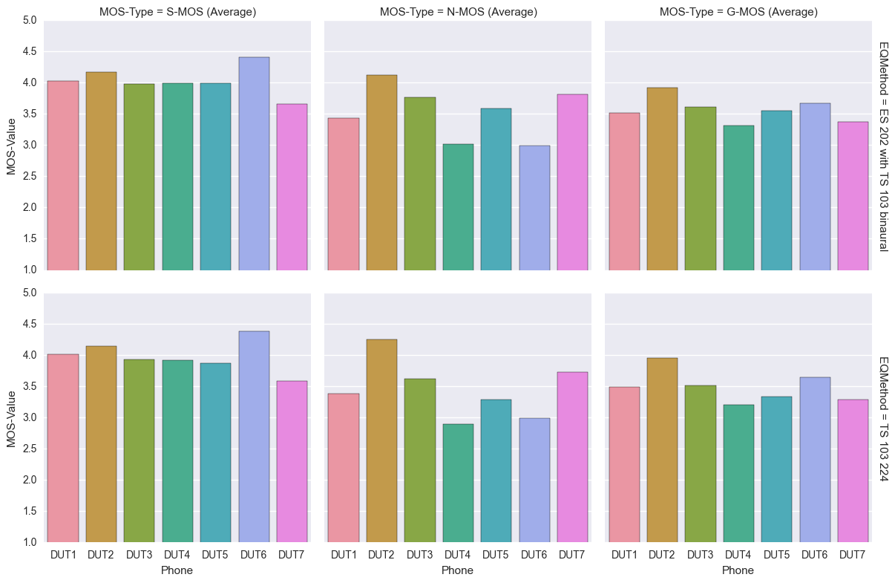
Figure 77: Absolute MOS-Values when values are averaged over all background noises and all labs

TS 103 224 - ES 202 396-1 with noises from TS 103 224
When using the binaurally recorded background noises from TS 103 224 for the tests the differences when comparing ES 202 396-1 with TS 103 224 (see Figure 78) are slightly higher than the deviations observed in HHHFT mode (see Figure 41). The offset is not constant but depending on the type of terminal. The performance for all terminals is better when using the ES 202 396-1.Surprisingly the performance for all terminals except DUT2 is slightly better when using the ES 202 396-1 simulation method compared to the sound field simulation technique described in TS 103 224.

G-MOS  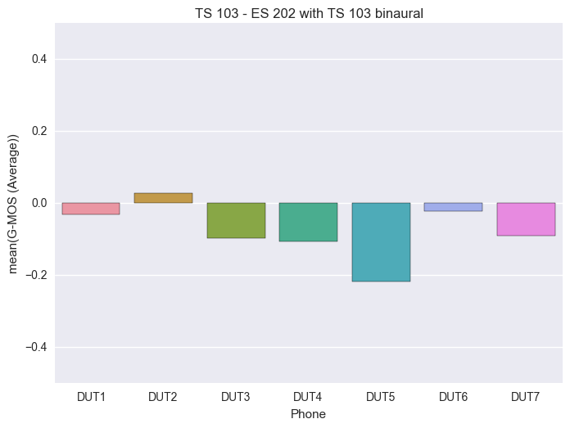 | S-MOS  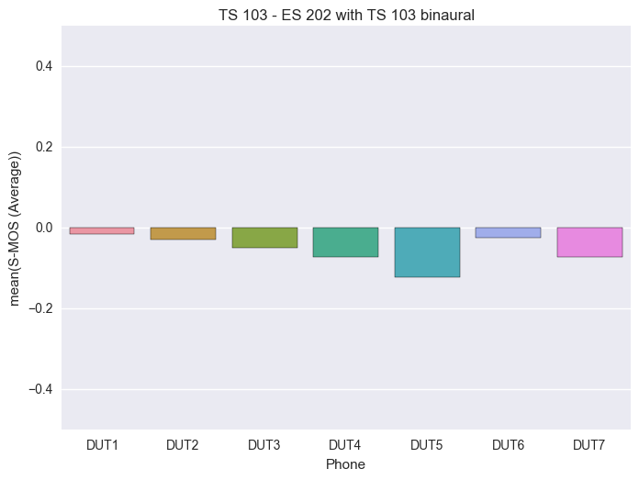

N-MOS
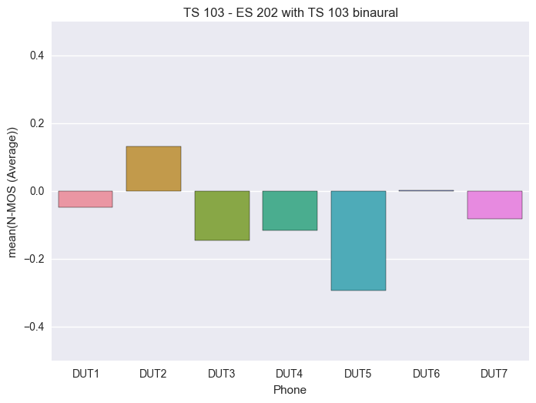
Figure 78: Differences of MOS-values between method from TS 103 224 and ES 202 396-1 with noises from TS 103 224

Narrowband

Absolute Values
The results in Figure 79 show the same tendency for all phones when measured using the different background noise simulation setups. The rank order in performance remains unchanged.
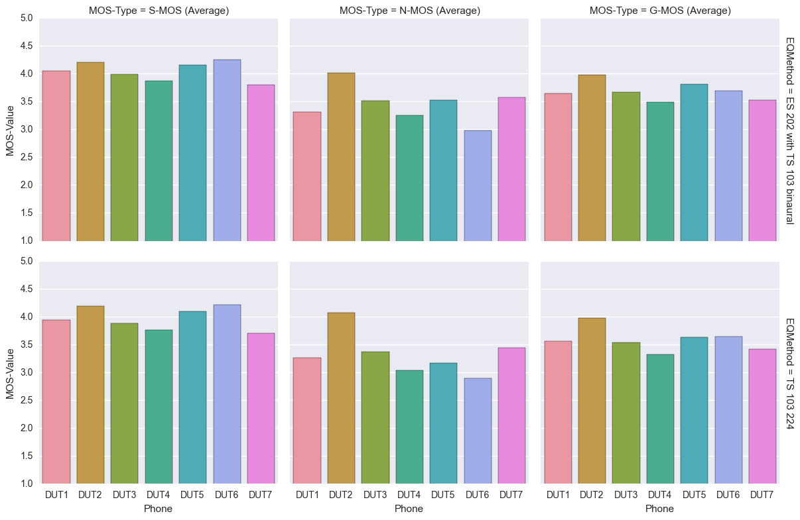
Figure 79: Absolute MOS-Values when values are averaged over all background noises and all labs

TS 103 224 - ES 202 396-1 with noises from TS 103 224
When using the binaurally recorded background noises from TS 103 224 for the tests the differences when comparing ES 202 396-1 with TS 103 224 (see Figure 80) are slightly higher than the deviations observed in HHHFT mode (see Figure 44). The offset is not constant but depending on the type of terminal. The performance for all terminals is better when using the ES 202 396-1.Surprisingly the performance for all terminals except DUT2 is slightly better when using the ES 202 396-1 simulation method compared to the sound field simulation technique described in TS 103 224.

G-MOS  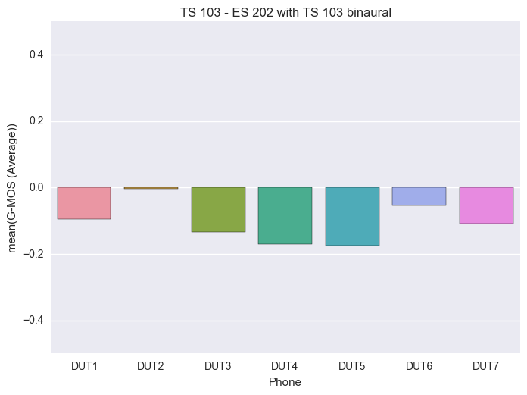 | S-MOS  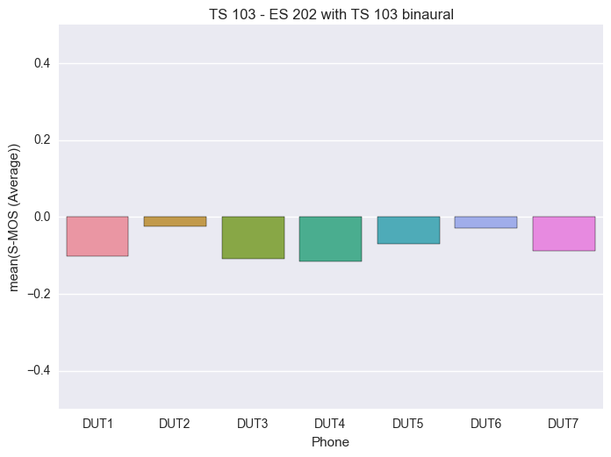

N-MOS
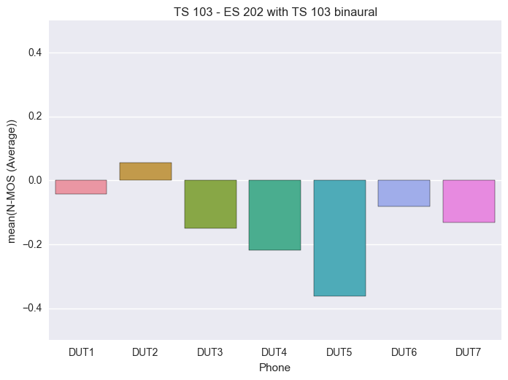
Figure 80: Differences of MOS-values between method from TS 103 224 and ES 202 396-1 with noises from TS 103 224

DTHF: Analyses of the noise spectra reproduced at the reference microphone

Simulation acc. to ES 202 396-1 with recordings from TS 103 224, reference recording at place of DUT-microphone

As for already seen for the HHHFT experiments quite big differences can be found in the spectra reproduced by the ES 202 396-1 simulation method in the different labs.
The differences range from 5 dB up to 15 dB. Consistently big differences are found in the low frequency domain.

Desktop Office
Figure 81: All spectra recorded at reference microphone for cafeteria noise with method from ES 202 396-1 and noises from TS 103 224 in 1/3rd octave

Simulation & Recordings acc. to TS 103 224, reference recording at place of DUT-microphone
The differences in the spectra reproduced by the TS 103 224 simulation method are significantly lower compared to the ES 202 396-1 simulation method. The differences seem to be independent of the noise type.
The differences range from 1 dB up to 8 dB. As expected the sound field reproduction is very consistent between labs in the low frequency domain up to about 2 kHz, there where the maximum of energy is found. The spectral differences are in the range of 1-2 dB. Up to about 8 kHz the differences are still less than 5 dB from 10 -20 kHz the differences remain below 8 dB.

Desktop Office
Figure 82: All spectra recorded at reference microphone for cafeteria noise with method from TS 103 224 in 1/3rd octave

Conclusions
The following conclusions can be drawn from the Round Robin Experiment:
- In general the inter-lab consistency of the results is good.
- When using the background noises from ES 202 396-1 [2] somewhat higher performance results can be expected due to the different nature of the background noises and the different signal levels especially for Cafeteria noise and train station noise
- When using the binaurally recorded background noises from TS 103 224 [3] for the tests the differences when comparing ES 202 396-1 [2] with TS 103 224 [3] are small. The offset is not constant but depending on the type of terminal. The performance for all terminals is measured slightly better when using the ES 202 396 in hand-held HFT. For desktop HFT the variations observed are slightly bigger, the differences are not consistent.The inter-lab correlation when using TS 103 224 [3] is higher than with ES 202 396-1 [2]. For ES 202 396-1 the RMSE values are between 0.13 and 0.25. For TS 103 224 the RMSE values of the results between labs are in the range of 0.07 to 0.2.
- The differences when analyzing in hand-held hands-free mode according to the current version of TS 26.131 [5] and TS 26.132 [6] and averaging S-, N- and G-MOS over all background noises are small when comparing TS 103 224 and ES 202 396-1 with background noises from TS 103 224. The differences are in the range of 0.1 – 0.2 MOS. The differences are terminal dependent. Surprisingly the performance for all terminals is slightly better when using the ES 202 396-1 [2] simulation method compared to the sound field simulation technique described in TS 103 224 [3].
- When testing in Desktop position the differences when analyzing according to the current version of TS 26.131 [5] and TS 26.132 [6] and averaging S-, N- and G-MOS over all background noises are slightly bigger compared to hand-held hands-free mode. However, it should be noted that only 2 labs with 3 different rooms were participating in this experiment.
- The accuracy and consistency of the background noise reproduction at the terminal is significantly better especially in the low frequency domain below 2 kHz when using TS 103 224 [3]. Spectral differences measured at the reference microphone drop from 5-15 dB when measuring in 1/3rd octaves for the ES 202 396-1 [2] simulation method to 1-5 dB when using the TS 103 224 [3] simulation method. It was discussed whether might be possible to reduce the variability of the ES 202 396-1 sound field reproduction further by defining and validation the delays between the loudspeakers in a different way than it is currently made in ES 202 396-1. However, whether this is possible and leads to less variability is unknown and needs to be addressed in ETSI TC STQ.

References
- Tdoc SQ-AHQ099: Proposed test plan for a Round Robin Test for comparison of background noise simulations – Rev. 1
- ETSI ES 202 396-1: Speech quality performance in the presence of background noise; Part 1: Background noise simulation technique and background noise database
- ETSI TS 103 224: A sound field reproduction method for terminal testing including a background noise database
- Tdoc S4-151040: ATeMPO_SPINE round-robin tests conducted at Sony, Sony Mobile Communications
- 3GPP TS 26.131: Terminal acoustic characteristics for telephony; Requirements (Release 12)
- 3GPP TS 26.132: Speech and video telephony terminal acoustic test specification (Release 12)
- Tdoc S4-AHQ101: Report on ATeMPO_SPINE round-robin tests conducted at Orange, Orange
- S4 151354: ATeMPO-SPINE round-robin tests conducted at Knowles, Knowles Inc.
- S4 151343: Report on ATeMPO_SPINE round-robin tests conducted at HEAD acoustics , HEAD acoustics GmbH

